**SESSION 5**

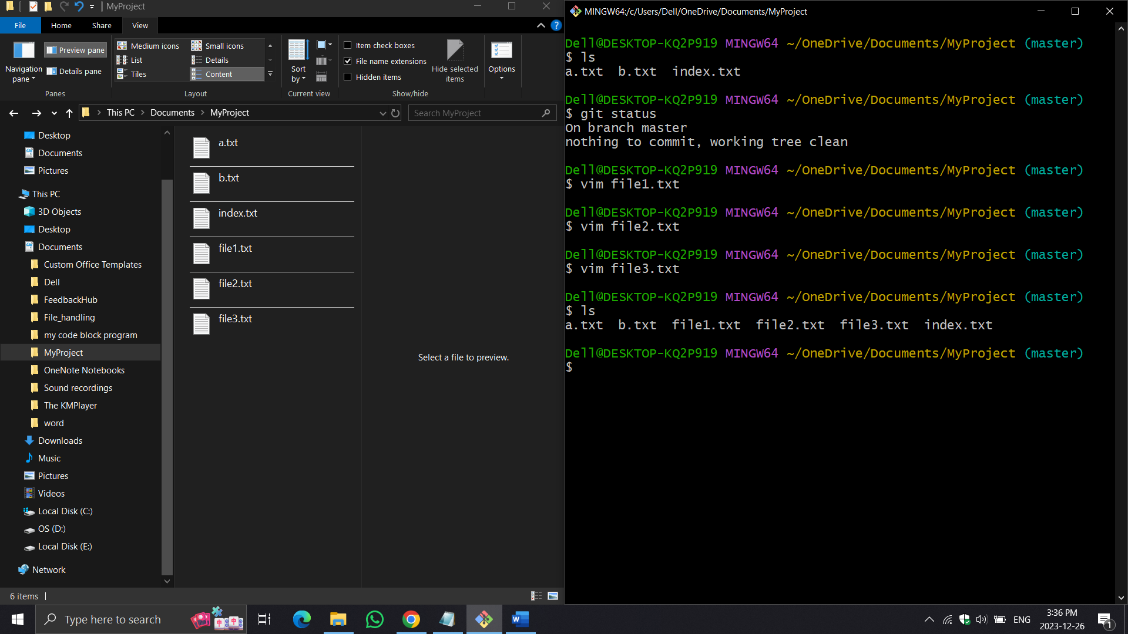First, create three files:

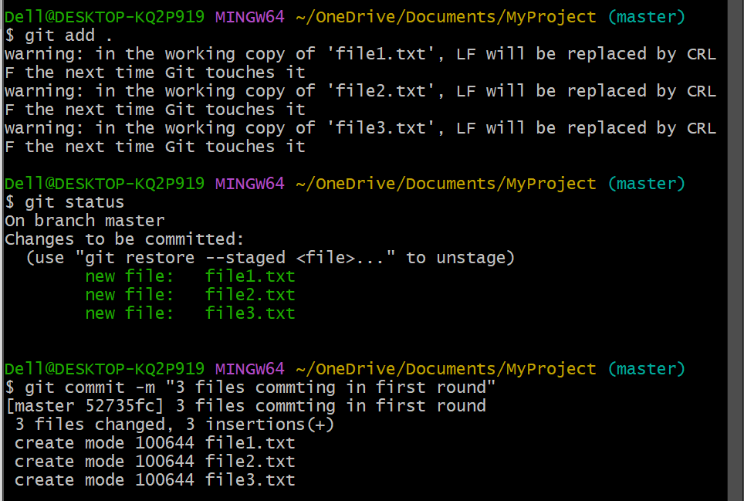Then add them to staging area and commit them

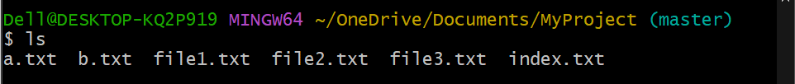To see name of all file in the working directory

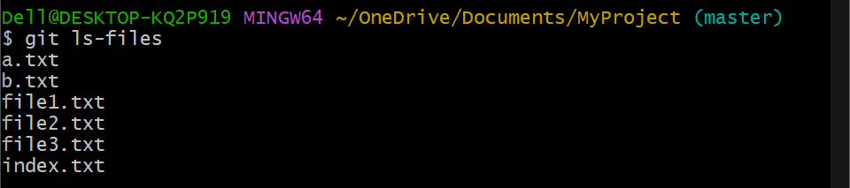To see name of the file in staging area :-

**Git rm command (rm - remove)**

Requirement 1 :- Remove files both from staging & working directory

To remove specific file give file name 🡪 $ git rm file1.txt

To remove all file 🡪 $ git rm -r .

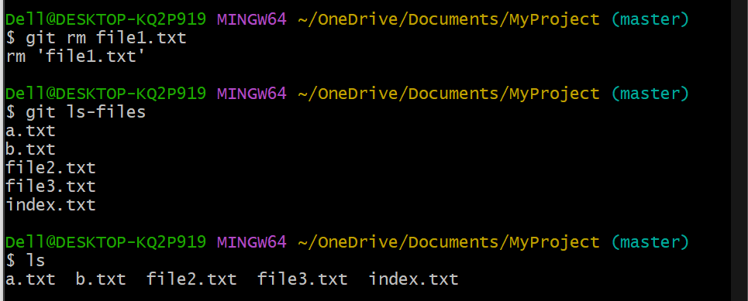

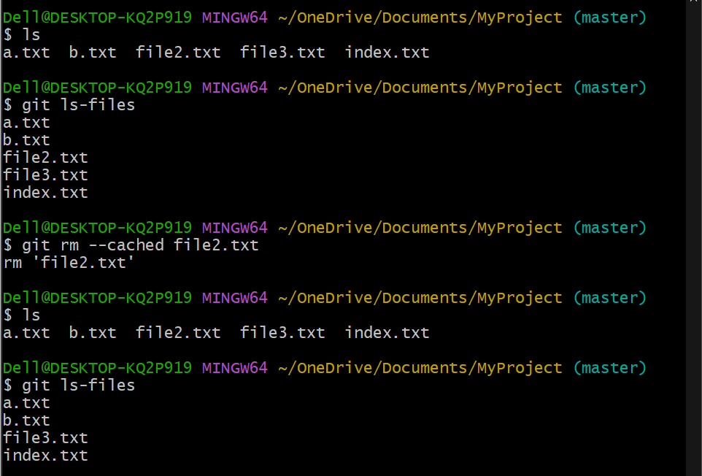Requirement 2 :- Remove files only from staging area

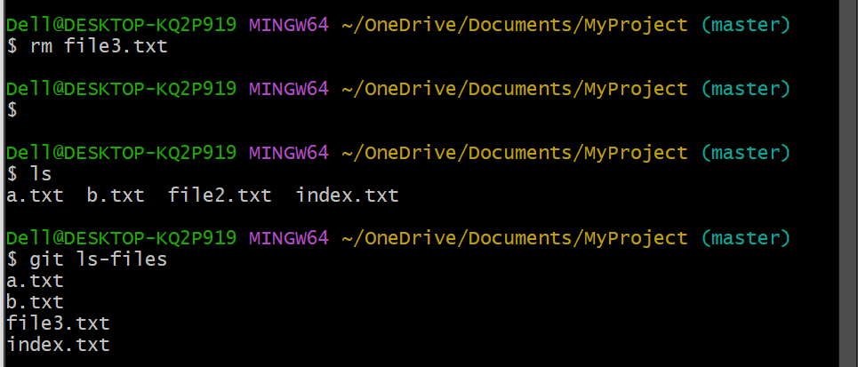Requirement 3 :- Remove files only from working directory